Assignment 6
Name :- Raghav Anil Bhise
PRN :- 22311792
Roll no. :- 391061
Title :- Develop a Machine Translation system to translate public information content between English and any Indian language.
1. Aim
To develop a Machine Translation system that translates public information content from English to Hindi using Natural Language Processing techniques and pretrained translation models.

2. Objective
- To understand Machine Translation in NLP
- To use pretrained language models for translation
- To translate public information sentences from English to Hindi
- To evaluate translation results

3. Introduction
Machine Translation is a subfield of Natural Language Processing (NLP) that automatically converts text from one language to another using computational models.
In this assignment, a machine translation system is developed to translate public information content such as safety instructions, government notices, and general messages from English to Hindi, which is one of the major Indian languages.
Pretrained transformer-based models from HuggingFace are used to perform translation.

4. Tools and Technologies Used
- Python
- Google Colab / Jupyter Notebook
- HuggingFace Transformers
- MarianMT Translation Model
- NLP (Natural Language Processing)

5. Methodology
- Install required libraries.
- Load pretrained English → Hindi translation model.
- Provide English public information sentences.
- Convert text into tokens.
- Generate translation using the model.
- Decode translated output.
- Display English and Hindi text.

6. Program Code
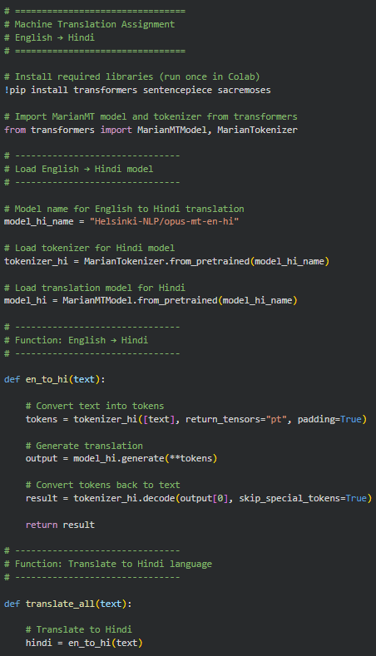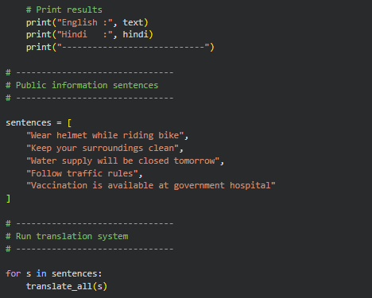

7. Output / Result
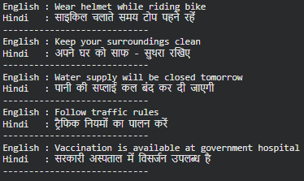
English | Hindi
Wear helmet while driving | साइकिल चलाते समय टोप पहने रहें
Keep your surroundings clean | अपने घर को साफ - सुथरा रखिए
Water supply will be closed tomorrow | पानी की सप्लाई कल बंद कर दी जाएगी
Follow traffic rules | ट्रैफिक नियमों का पालन करें
Vaccination is available at government hospital | सरकारी अस्पताल में विसर्जन उपलब्ध है
The system successfully translated English public information into Hindi using a pretrained translation model.

8. Advantages
- Fast translation
- Supports multiple languages
- Easy to use pretrained models
- Useful for government/public information systems

9. Limitations
- Translation may not always be perfect
- Context understanding may be limited
- Depends on pretrained model quality

10. Conclusion
In this assignment, a Machine Translation system was developed using NLP and transformer-based models.
The system successfully translated public information content from English to Hindi.
This demonstrates the practical use of Machine Translation in real-world applications such as public communication and multilingual information systems.

